**ABSTRACT**

The rapid growth of online learning platforms has led to an overwhelming number of available courses, making it challenging for students to find the most suitable options. To address this issue, we developed **"Find A Right Web: A Student App"**, a multi-company course aggregator that centralizes course discovery from various platforms. Built using **HTML, CSS, and JavaScript**, the application features a **responsive and intuitive user interface** that enhances user experience.

We collected and organized **extensive course data** from multiple sources to ensure comprehensive aggregation. Beyond development, we actively participated in **project planning, marketing strategies, and stakeholder engagement** to maximize the project's impact and outreach.

This application not only streamlines the course selection process but also sets the foundation for future enhancements, including **personalized career pathways and blockchain-based certificate verification**. By leveraging modern web technologies and data-driven insights, **Find A Right Web** empowers students to make informed learning decisions.

**INDEX**

|  |  |  |
| --- | --- | --- |
| S.No | Chapter Title | Page No. |
| 1 | **Abstract** | **2** |
| 2 | **About the Project** | **4 - 5** |
| 3 | **Literature Survey** | **6 - 7** |
| 4 | **System Analysis** | **8 – 9** |
| 5 | **System Design** | **10 - 11** |
| 6 | **System Requirements Specification** | **12 - 13** |
| 7 | **Methodology** | **14 - 15** |
| 8 | **System Testing** | **16** |
| 9 | **Implementation and Results** | **17 - 52** |
| 10 | **Conclusion** | **53** |
| 11 | **Future Enhancement** | **53** |
| 12 | References | 54 |

**INTRODUCTION**

# ABOUT THE PROJECT

**Find A Right Web: A Student App** is a web-based application designed to help students efficiently discover and compare online courses from various e-learning platforms in one centralized location. The goal of this project is to eliminate the confusion caused by scattered course information across different websites by aggregating and displaying them through a clean and user-friendly interface.

Developed using **HTML, CSS, and JavaScript**, the application provides a responsive frontend that enhances accessibility and usability. The project involved **collecting and organizing large volumes of course data**, which was then processed and presented in a structured format. To improve course suggestions and user experience, basic **AI-driven optimization techniques** were integrated for recommending courses based on preferences and trends.

In addition to development, the project team actively participated in **planning, design, marketing, and strategic future planning**. Proposed enhancements include personalized learning paths and certificate verification features. Overall, the project aims to empower students with smarter course selection tools, contributing to more effective and personalized learning journeys.

In north Indian student developed an app all social media apps together created an single app.

Why? should we don’t do for studies and useful things as thought started. and I analyze the things which coming to mine.

For best things the application which is the useful for every student, there get all information in an single app which had best features and best User interface.

The quality of information that should delivers all students and many sike learner and so on. Being to get all things right them.

Mainly the things need for this Data collections, data cleaning, Content creation, Designing, Coding, Testing, Execution, Deployment etc…

As a part of that we need forward this as much higher.

# OBJECTIVE

• To develop a centralized platform for aggregating online courses from multiple educational websites.

• To simplify the course discovery process for students through a clean and user-friendly interface.

• To integrate basic AI techniques for optimizing course recommendations based on user interests.

• To ensure responsive and accessible design using core web technologies like HTML, CSS, and JavaScript.

• To plan for future enhancements such as personalized learning paths and verified certifications.

• To explore real-world application through marketing, outreach, and usability improvements

**2.2 PROBLEM STATEMENT**

With the increasing number of online learning platforms offering thousands of courses, students often face difficulty in choosing the right course that aligns with their goals and interests. Manually browsing through various sites is time-consuming and inefficient. There is a need for a unified platform that aggregates and intelligently recommends relevant courses in one place. And for career platforms.

**2.3 SCOPE OF THE PROJECT**

* Aggregates course data from popular platforms such as Coursera, Udemy, and edX (data handled manually in this version).
* Provides a user-friendly interface for searching, filtering, and viewing course details.
* Incorporates basic AI features to recommend courses based on interest areas.
* Focuses on frontend development using web technologies (HTML, CSS, JS).
* Plans for future integration of smart features like certification tracking, user authentication, and learning analytics.

**2.4 TOOLS AND TECHNOLOGIES USED**

* **HTML5** – For page structure and content layout
* **CSS3** – For styling and responsive design
* **JavaScript** – For dynamic interactivity and basic logic handling
* **Google Sheets / JSON** – (Optional) For managing and storing collected course data

# LITERATURE SURVEY

1. **LITERATURE SURVEY**

The increasing availability of Massive Open Online Courses (MOOCs) has revolutionized digital learning, but it has also created a fragmented ecosystem where learners must search across various platforms to find suitable courses. A number of studies and tools have been proposed to address this issue, each with unique approaches to aggregating, filtering, and personalizing course content.

**Existing Platforms and Systems**

* **Coursera, Udemy, edX, and Skillshare** are leading MOOC providers offering thousands of courses. However, each functions independently, with no unified portal for comparison or integration.
* **Career guidance platforms like Internshala, Naukri Learning, and LinkedIn Learning** provide job-oriented training and upskilling suggestions but are often limited to their own ecosystem or partner organizations.
* **AI-enabled platforms like Class Central** attempt to list and review MOOCs from multiple providers, but their personalization features are limited.
* **Job portals like Indeed, Monster, and Glassdoor** offer integrated learning recommendations (in some cases), but lack deep course analysis or customization based on user behavior.

**Gap Identified**

Despite the variety of platforms available, there is **no single tool that aggregates courses across multiple platforms while also integrating career guidance and multi-company job portals** in a personalized manner. Many systems either:

* Focus solely on course discovery without real-time guidance.
* Lack integration with job/career portals that align courses with employment opportunities.
* Don’t provide a simplified and clean user experience for students unfamiliar with tech-heavy dashboards.

**Proposed Solution**

Our project, **Find A Right Web: A Student App**, addresses these gaps by:

* Aggregating course data from **multiple learning platforms** in one place.
* Including **career portal features** by linking with opportunities from various companies (internships, jobs, and training programs).
* Using **basic AI techniques** to recommend personalized learning paths based on user interests and market demand.
* Planning for future integration with **job portals and career counseling platforms**, aligning course learning directly with job readiness.

**SYSTEM ANALYSIS**

1. **SYSTEM ANALYSIS**

System Analysis involves understanding the project’s requirements, identifying problems in existing systems, and defining the structure of the proposed solution. In the case of **Find A Right Web: A Student App**, the analysis focuses on how to streamline the course selection process and integrate career opportunities across platforms for students.

**4.1 Existing System**

Currently, students must visit multiple educational platforms such as Coursera, Udemy, edX, etc., to search for relevant courses. These platforms do not provide centralized access or comparative features. Additionally, **career portals** and **job platforms** function independently from educational sites, creating a disconnect between learning and employment.

**Limitations of the Existing System:**

* No unified interface for accessing courses from multiple providers.
* Difficulty in comparing course content, pricing, and reviews.
* Lack of intelligent recommendations tailored to student interests or career goals.
* No link between courses and job opportunities or career guidance.
* Time-consuming manual search process across different platforms.

**4.2 Proposed System**

The **Find A Right Web** application addresses the above challenges by offering a centralized, web-based solution that brings together:

* Aggregated course data from various educational platforms.
* Basic **AI-driven recommendation logic** to help users find suitable courses.
* Integration with **career portals and job listings** to provide career-aligned learning suggestions.
* A clean, responsive, and user-friendly interface built with **HTML, CSS, and JavaScript**.

**Key Features:**

* Centralized dashboard for viewing multiple courses from different platforms.
* Search and filter options for personalized course discovery.
* Integration of basic career portal links and company listings.
* AI-based suggestion engine to optimize course recommendations.
* Plans for future enhancements like certification tracking and user login.

**Feasibility Study**

* **Technical Feasibility:** The project is built using standard web technologies (HTML, CSS, JS) and is deployable on any modern web server. It uses publicly available course data and simple recommendation logic.
* **Economic Feasibility:** Since it is a student-led project with open-source tools, the development cost is minimal. The system is scalable and can be expanded later.
* **Operational Feasibility:** The app is simple to use, even for non-technical users. Future versions can include admin dashboards for educational partners.

**RULES & ETHICS**

**Here are four key points to take away:**

* Comparative advertising is generally permissible as long as it’s not misleading, confusing, disparaging, or untruthful.
* Brands can use comparison surveys and publish results, provided they can back up their claims.
* It’s usually acceptable to reference another brand or their trademarks as long as there’s no intent to capitalize on consumer confusion or the brand’s reputation.
* Compatibility assurances can be used in advertising, but it should not create an impression of endorsement or affiliation between the two companies.

# TYPE

Based on the information provided, the project appears to be a App development project aimed at implementing a many things. Specifically, it involves the design and development of a platform that enables users to view the many websites presenting or providing courses through different sources. The project is large sources having many things data gathering where as websites are many too, need gather many and the cleaning process make over lot of things.

✔ **Competitor Analysis:**

| **Platform** | **Focus** | **Weakness** |
| --- | --- | --- |
| Coursera | University & company courses | Generic learning paths |
| Udemy | Individual instructor courses | No direct company verification |
| LinkedIn Learning | Corporate skill-building | Limited free content |
| OpenSesame | Enterprise training | Expensive, not student-friendly |

# SYSTEM DESIGN

1. **SYSTEM DESIGN**

System Design is the blueprint of the software architecture. It defines the structure, components, data flow, and interactions that make up the system. For **Find A Right Web: A Student App**, the system design ensures a seamless and user-friendly experience while managing data efficiently.

**Architectural Overview**

The project follows a **client-side web architecture**, where the application runs directly in the user's browser using **HTML, CSS, and JavaScript**. The system is designed for easy scalability, with future plans to integrate backend support and AI models for smarter functionalities.

**Key Components:**

* **User Interface Layer (Frontend)**  
  Built using HTML, CSS, and JavaScript for layout, styling, and interactivity.
* **Data Layer (Static / External Sources)**  
  Course data is collected manually or fetched through APIs (if available) from platforms like Coursera, Udemy, etc.
* **Recommendation Logic (Frontend-Based)**  
  Simple AI-like logic (e.g., keyword matching, category-based filtering) is implemented to simulate recommendation features.

**System Components**

| **Component** | **Description** |
| --- | --- |
| **Home Page** | Entry point with overview, search bar, and featured courses. |
| **Course Aggregator** | Displays courses collected from various platforms in a unified format. |
| **Search & Filter** | Allows users to search for courses by category, provider, or keyword. |
| **Recommendation Engine** | Basic logic to suggest courses based on user's interests or trends. |
| **Career Portal Integration** | Links to job openings, internship opportunities, and company profiles. |
| **Future Planning Modules** | Placeholder sections for upcoming features like login, blockchain, etc. |

**Data Flow Diagram (Level 1)**

[User]

↓

[Web Interface (HTML/CSS/JS)]

↓

[Course Data (Static/API)] ←→ [Recommendation Logic]

↓

[Course Display + Career Links]

**User Interface Design**

The UI is designed to be:

* **Responsive** – Works across mobile and desktop devices.
* **Minimalist** – Clean layout to reduce user confusion.
* **Interactive** – Smooth transitions, clickable cards, and filters.

Tools like **Figma or Canva** were optionally used for wireframing and design mockups.

**Future Enhancements in System Design**

* Backend integration using Node.js or Django for dynamic data handling.
* Database implementation (MongoDB or PostgreSQL) for storing user profiles and preferences.
* AI model training using TensorFlow or Scikit-learn for advanced recommendation.
* Admin panel for managing courses and career postings.
* Blockchain module for certificate validation.

**SYSTEM REQUIREMENTS SPECIFICATION**

1. **SYSTEM REQUIREMENTS SPECIFICATION (SRS)**

The System Requirements Specification outlines both the functional and non-functional requirements of the application. It serves as a guideline for development, testing, and future enhancement.

**Functional Requirements**

These are the features the system must support:

* **Course Aggregation**
  + Display courses from multiple e-learning platforms (e.g., Coursera, Udemy, edX).
  + Allow users to view basic information like course name, platform, price, and description.
* **Search and Filter**
  + Enable users to search for courses using keywords.
  + Provide filters based on categories, difficulty level, and price (free/paid).
* **Recommendation Logic**
  + Suggest courses based on user-selected categories or interests using frontend logic (e.g., JavaScript filtering).
* **Career Portal Integration**
  + Provide links to career-related resources, internships, and job portals.
  + Display a list of companies and career opportunities aligned with user-selected courses.
* **Responsive UI**
  + Ensure that the interface works across various screen sizes (desktop, tablet, mobile).
* **Future Enhancements Placeholder**
  + Include placeholder sections or prompts for upcoming features such as login/signup, saved courses, and certification tracking.

**Non-Functional Requirements**

These define the quality attributes and constraints of the system:

* **Usability**
  + The application should be intuitive and easy to navigate, even for non-technical users.
* **Performance**
  + Pages should load within 2–3 seconds on standard internet connections.
  + Must support smooth scrolling and transitions between sections.
* **Scalability**
  + Designed in a way that supports future backend and database integration.
* **Maintainability**
  + The code should be clean, well-documented, and easy to update.
* **Portability**
  + The web app should work consistently across major browsers like Chrome, Firefox, and Edge.
* **Availability**
  + Hosted on a reliable platform like GitHub Pages or Netlify for continuous public access.

**Software Requirements**

| **Component** | **Requirement** |
| --- | --- |
| **Frontend** | HTML5, CSS3, JavaScript |
| **Code Editor** | Visual Studio Code / Sublime Text |
| **Design Tools (optional)** | Figma / Canva |
| **Version Control** | Git, GitHub |
| **Browser** | Chrome / Firefox / Edge |
| **Hosting Platform** | GitHub Pages / Netlify |

**1.9.4 Hardware Requirements**

| **Component** | **Minimum Requirement** |
| --- | --- |
| **Processor** | Intel i3 or equivalent |
| **RAM** | 4 GB |
| **Hard Disk** | 500 MB of free space |
| **Display** | 13” screen with 1024×768 resolution |
| **Internet** | Required for testing and deployment |

# project-folder

# ├── about.html

# ├── career.html

# ├── courses.html

# ├── index.html

# ├── login.html

# ├── profile.html

# ├── style.css

# ├── login.js

# ├── index.js

**METHODOLOGY**

1. **METHODOLOGY**

The development of **Find A Right Web: A Student App** followed a structured and iterative approach, focusing on user-centric design, efficient data handling, and scalability. The project was carried out in multiple phases, from requirement analysis to implementation, testing, and planning for future enhancements.

**Phase 1: Requirement Analysis**

* Identified the core problem: the scattered availability of online courses across different platforms.
* Defined user needs such as easy course discovery, company-specific career guidance, and a clean UI.
* Outlined functional and non-functional requirements.

**Phase 2: Planning and Design**

* Created wireframes and mockups using **Canva/Figma** to visualize the app layout.
* Decided on a **frontend-only architecture** using **HTML, CSS, and JavaScript**.
* Structured the layout to include sections for course listings, search/filter options, and career portal links.

**Phase 3: Data Collection and Integration**

* Manually gathered data from multiple course platforms like Coursera, Udemy, and edX.
* Organized this data in structured formats (e.g., JSON, tables) for easy integration into the frontend.
* Collected details about companies and job portals to link career opportunities with relevant courses.

**Phase 4: Development**

* Developed the frontend using:
  + **HTML** for structuring pages.
  + **CSS** for styling and responsive design.
  + **JavaScript** for interactivity, filtering, and simple AI-based recommendations.
* Created dynamic sections for course display and integrated static career portal links.
* Ensured responsive behavior across devices and browsers.

**Phase 5: AI Optimization (Basic)**

* Used simple JavaScript logic for **keyword matching**, **interest-based filtering**, and **category tagging**.
* Planned future implementation of more advanced AI/ML models for better personalization.

**Phase 6: Testing and Debugging**

* Performed **manual testing** across different browsers and devices.
* Checked all interactive features like filtering, course viewing, and responsive design.
* Fixed layout bugs and optimized code for better performance.

**Phase 7: Deployment and Marketing**

* Hosted the project using **GitHub Pages / Netlify** for public access.
* Created posters, demo videos, and shared the project through social media and academic networks.
* Collected feedback for continuous improvement.

**Phase 8: Future Planning**

* Proposed features such as:
* User login/signup
* Saved courses
* Certificate verification using blockchain
* Smart AI recommendations using TensorFlow
* Admin dashboard for career partner companies

1. **SYSTEM TESTING**

**SYSTEM TESTING**

System Testing is a crucial phase in the software development lifecycle where the complete system is evaluated to ensure that it meets the specified requirements and functions correctly. In the case of **Find A Right Web: A Student App**, testing focused on functionality, usability, compatibility, and performance.

**Types of Testing Performed**

1. **Functionality Testing**
   * Verified that all features like course display, search, filtering, and career portal links are working as intended.
   * Ensured course data is properly loaded and shown in the correct layout.
2. **Usability Testing**
   * Conducted testing with a few users (students) to ensure the interface is easy to navigate.
   * Collected feedback on user experience and made improvements to design and navigation flow.
3. **Compatibility Testing**
   * Checked app behavior across major browsers: Chrome, Firefox, Microsoft Edge.
   * Ensured responsiveness on different devices: mobile phones, tablets, and desktops.
4. **Performance Testing**
   * Verified that all pages load quickly and smoothly, with no lag or excessive loading time.
   * Optimized image sizes and minimized code to improve load speed.
5. **Interface Testing**
   * Checked the integration between the UI and manually collected course data.
   * Ensured proper linking of career portals and company pages.

**Test Cases Example**

| **Test Case ID** | **Test Description** | **Expected Result** | **Actual Result** | **Status** |
| --- | --- | --- | --- | --- |
| TC01 | Load homepage | Homepage loads with title and sections | As expected | Pass |
| TC02 | Search for "Python" courses | Courses related to Python are displayed | As expected | Pass |
| TC03 | Click on company career portal link | Redirects to company website | As expected | Pass |
| TC04 | View course details layout on mobile screen | Layout adjusts properly for small screens | As expected | Pass |
| TC05 | Filter courses by category | Only selected category courses appear | As expected | Pass |

**Conclusion of Testing**

System testing confirms that the application is stable, responsive, and functions as expected across platforms and devices. The testing phase also contributed to enhancing the UI/UX and optimizing performance. The system is now ready for deployment and further development.

# 9. IMPLEMENTATION AND RESULT

**IMPLEMENTATION**

The **Find A Right Web: A Student App** was implemented using a combination of modern web development technologies and a systematic approach that ensured the successful delivery of a user-friendly, informative platform for students.

**Implementation Details**

The implementation was divided into several key modules to simplify development and ensure maintainability:

1. **Frontend Development**
   * Built using **HTML** for structure, **CSS** for design and layout, and **JavaScript** for interactivity and dynamic content handling.
   * Implemented a responsive layout to ensure the application works seamlessly on all screen sizes and devices.
2. **Course Aggregator Module**
   * Collected and manually organized data from platforms like Coursera, Udemy, and edX.
   * Displayed courses using dynamic cards categorized by platform, subject, and popularity.
3. **Search and Filter Feature**
   * JavaScript was used to allow users to search for specific keywords.
   * Category-based filters helped narrow down course selections based on user interests.
4. **Recommendation System (Basic AI)**
   * Implemented rule-based recommendation logic using JavaScript.
   * Based on user input or preferences, the system highlighted suitable courses.
5. **Career Portal Integration**
   * Added sections linking to different company career pages, internships, and job platforms.
   * Designed to align learning outcomes with job opportunities for better career mapping.
6. **Hosting and Deployment**
   * The web app was hosted using **GitHub Pages**/**Netlify**, allowing easy access to the public.
   * Regular commits and updates were made through Git version control.

**Results**

The final version of the application met all planned requirements and provided a functional and visually appealing platform for students:

| **Goal** | **Achieved Outcome** |
| --- | --- |
| Unified course platform | Successfully integrated multiple course providers into one portal |
| Easy course discovery | Effective search and filter functionalities implemented |
| Personalized recommendations | Basic logic helped in highlighting relevant courses to users |
| Job-oriented learning | Career links helped students connect learning with real-world jobs |
| Mobile-friendly access | Responsive design ensured smooth access across devices |

**Conclusion of Implementation**

The implementation of the system was completed successfully, within scope and timeline. The project proved to be practical, informative, and easily extendable for future use. The results clearly demonstrated the need and usefulness of such a centralized platform for students navigating both learning and career development.

# CODE:

**Login.html**

<!DOCTYPE html>

<html lang="en">

<head>

  <meta charset="UTF-8" />

  <meta name="viewport" content="width=device-width, initial-scale=1.0" />

  <title>Find a Right Web - Student App | Login</title>

  <link rel="stylesheet" href="style.css" />

  <!-- Google Fonts -->

  <link href="https://fonts.googleapis.com/css2?family=Poppins:wght@300;400;600&display=swap" rel="stylesheet" />

</head>

<body class="netflix-bg">

  <header class="login-header">

    <h1 class="app-logo" aria-label="Find a Right Web">Find a Right Web</h1>

  </header>

    <div class="login-container">

    <div class="login-card">

      <h2>Sign In to Find a Right Web</h2>

      <p>Choose one method below</p>

      <!-- Phone Number Login -->

      <div class="form-group" id="phone-group">

        <input type="tel" id="phoneInput" class="form-control" placeholder="Phone Number" aria-label="Phone Number">

        <button id="sendOtpBtn" class="btn">Send OTP</button>

      </div>

      <div class="form-group hidden" id="otp-group">

        <input type="text" id="otpInput" class="form-control" placeholder="Enter OTP" aria-label="Enter OTP">

        <button id="verifyOtpBtn" class="btn">Verify OTP</button>

      </div>

      <div class="divider">OR</div>

      <!-- Google Sign In -->

      <div class="form-group">

        <button id="googleSignInBtn" class="google-btn" aria-label="Sign in with Google">

          <img src="https://via.placeholder.com/20?text=G" alt="Google Logo" class="google-logo" loading="lazy">

          Sign in with Google

        </button>

      </div>

      <div id="loginMessage" class="message" role="alert"></div>

    </div>

  </div>

 <script src="login.js"></script>

</body>

</html>

**Index.html** :

<!DOCTYPE html>

<html lang="en">

<head>

  <meta charset="UTF-8" />

  <meta name="viewport" content="width=device-width, initial-scale=1.0" />

  <title>Find a Right Web - Home</title>

  <link rel="stylesheet" href="style.css" />

  <!-- Google Fonts -->

  <link href="https://fonts.googleapis.com/css2?family=Poppins:wght@300;400;600&display=swap" rel="stylesheet" />

  <!-- Bootstrap 5 CSS (for Carousel) -->

  <link href="https://cdn.jsdelivr.net/npm/bootstrap@5.3.0/dist/css/bootstrap.min.css" rel="stylesheet">

</head>

<body class="netflix-bg">

  <!-- Navbar -->

  <header class="main-header">

    <div class="navbar">

      <button class="menu-toggle" id="menuToggle" aria-label="Toggle Menu">☰</button>

      <nav class="nav-links">

        <a href="index.html" class="nav-btn active">Home</a>

        <a href="courses.html" class="nav-btn">Courses</a>

        <a href="career.html" class="nav-btn">Career</a>

        <a href="about.html" class="nav-btn">About</a>

        <a href="profile.html" class="nav-btn">Profile</a>

      </nav>

      <div class="app-logo-index">Find a Right Web</div>

      <button id="logoutBtn" class="logout-btn" aria-label="Logout">Logout</button>

    </div>

  </header>

  <main class="container my-4">

    <!-- Animated Welcome Section -->

    <section class="welcome-section">

      <h2 class="welcome-title animate-fade-in">Welcome to Find a Right Web</h2>

      <p class="welcome-text animate-slide-in">

        Your gateway to the best courses and career opportunities. Explore, learn, and get inspired!

      </p>

    </section>

    <!-- Carousel Section -->

    <section class="carousel-section my-4">

      <div id="homeCarousel" class="carousel slide" data-bs-ride="carousel">

        <div class="carousel-inner">

          <div class="carousel-item active">

            <img src="https://source.unsplash.com/random/1200x400?education" class="d-block w-100" alt="Education Image 1">

            <div class="carousel-caption d-none d-md-block">

              <h5>Expand Your Knowledge</h5>

              <p>Access thousands of online courses from top institutions.</p>

            </div>

          </div>

          <div class="carousel-item">

            <img src="C:\Users\NITHIN SAI\OneDrive\Desktop\Find a right web- a student app\code\download.jpg" class="d-block w-100" alt="Career Image 2">

            <div class="carousel-caption d-none d-md-block">

              <h5>Kickstart Your Career</h5>

              <p>Discover career opportunities at leading companies.</p>

            </div>

          </div>

          <div class="carousel-item">

            <img src="https://source.unsplash.com/random/1200x400?technology" class="d-block w-100" alt="Tech Image 3">

            <div class="carousel-caption d-none d-md-block">

              <h5>Stay Ahead in Technology</h5>

              <p>Learn new skills and master modern technologies.</p>

            </div>

          </div>

        </div>

        <button class="carousel-control-prev" type="button" data-bs-target="#homeCarousel" data-bs-slide="prev" aria-label="Previous">

          <span class="carousel-control-prev-icon" aria-hidden="true"></span>

        </button>

        <button class="carousel-control-next" type="button" data-bs-target="#homeCarousel" data-bs-slide="next" aria-label="Next">

          <span class="carousel-control-next-icon" aria-hidden="true"></span>

        </button>

      </div>

    </section>

      <!-- Featured Resources Section -->

    <section class="featured-section my-4 animate-fade-in">

      <h2>Featured Resources</h2>

      <div class="featured-content">

        <img src="https://source.unsplash.com/random/600x400?learning" alt="Featured Resource" class="featured-img" loading="lazy">

        <div class="featured-info">

          <h3>Quality Courses</h3>

          <p>Discover a curated selection of high-quality courses designed to elevate your skills and knowledge.</p>

          <a href="courses.html" class="btn featured-btn">Explore Courses</a>

        </div>

      </div>

    </section>

  </main>

  <!-- Bootstrap JS Bundle -->

  <script src="https://cdn.jsdelivr.net/npm/bootstrap@5.3.0/dist/js/bootstrap.bundle.min.js"></script>

  <script src="index.js"></script>

</body>

</html>

**Courses.html:**

<!DOCTYPE html>

<html lang="en">

<head>

  <meta charset="UTF-8" />

  <meta name="viewport" content="width=device-width, initial-scale=1.0" />

  <title>Courses - Find a Right Web</title>

  <link rel="stylesheet" href="style.css" />

  <!-- Google Fonts -->

  <link href="https://fonts.googleapis.com/css2?family=Poppins:wght@300;400;600&display=swap" rel="stylesheet" />

</head>

<body class="netflix-bg">

  <!-- Navbar -->

  <header class="main-header">

    <div class="navbar">

      <button class="menu-toggle" id="menuToggle" aria-label="Toggle Menu">☰</button>

      <nav class="nav-links">

        <a href="index.html" class="nav-btn">Home</a>

        <a href="courses.html" class="nav-btn active">Courses</a>

        <a href="career.html" class="nav-btn">Career</a>

        <a href="about.html" class="nav-btn">About</a>

        <a href="profile.html" class="nav-btn">Profile</a>

      </nav>

      <div class="app-logo-index">Find a Right Web</div>

      <button id="logoutBtn" class="logout-btn" aria-label="Logout">Logout</button>

    </div>

  </header>

  <!-- Search and Filter -->

  <main class="container my-4">

    <div class="search-container">

      <input type="text" id="searchInput" class="search-input" placeholder="Search courses..." aria-label="Search courses" autocomplete="off">

      <select id="categoryFilter" class="filter-select" aria-label="Filter by Category">

        <option value="">All Categories</option>

        <option value="general">Online Learning Platforms</option>

        <option value="tech">Technology and Programming</option>

        <option value="business">Business and Management</option>

        <option value="creative">Creative Arts and Design</option>

        <option value="science">Science and Engineering</option>

        <option value="languages">Languages and Communication</option>

        <option value="personal">Personal Development</option>

        <option value="specialized">Specialized Skills and Certifications</option>

        <option value="free">Free Courses and Open Resources</option>

        <option value="hobby">Hobby and Niche Skills</option>

      </select>

    </div>

    <div id="grid" class="grid"></div>

    <div id="emptyState" class="empty-state">No courses found.</div>

  </main>

  <script src="index.js"></script>

</body>

</html>

**Career.html:**

<!DOCTYPE html>

<html lang="en">

<head>

  <meta charset="UTF-8" />

  <meta name="viewport" content="width=device-width, initial-scale=1.0" />

  <title>Career - Find a Right Web</title>

  <link rel="stylesheet" href="style.css" />

  <!-- Google Fonts -->

  <link href="https://fonts.googleapis.com/css2?family=Poppins:wght@300;400;600&display=swap" rel="stylesheet" />

</head>

<body class="netflix-bg">

  <!-- Navbar -->

  <header class="main-header">

    <div class="navbar">

      <button class="menu-toggle" id="menuToggle" aria-label="Toggle Menu">☰</button>

      <nav class="nav-links">

        <a href="index.html" class="nav-btn">Home</a>

        <a href="courses.html" class="nav-btn">Courses</a>

        <a href="career.html" class="nav-btn active">Career</a>

        <a href="about.html" class="nav-btn">About</a>

        <a href="profile.html" class="nav-btn">Profile</a>

      </nav>

      <div class="app-logo-index">Find a Right Web</div>

      <button id="logoutBtn" class="logout-btn" aria-label="Logout">Logout</button>

    </div>

  </header>

  <!-- Career Grid with Search -->

  <main class="container my-4">

    <div class="search-container">

      <input type="text" id="searchInput" class="search-input" placeholder="Search companies..." aria-label="Search companies" autocomplete="off">

    </div>

    <div id="careerGrid" class="grid"></div>

    <div id="emptyState" class="empty-state">No companies found.</div>

  </main>

  <script src="index.js"></script>

  <script>

    // On page load, if on career.html, render the career cards.

    const currentPage = window.location.pathname.split("/").pop();

    if (currentPage === "career.html") {

      displayCareerCards(careers);

    }

  </script>

</body>

</html>

**Profile.html:**

<!DOCTYPE html>

<html lang="en">

<head>

  <meta charset="UTF-8" />

  <meta name="viewport" content="width=device-width, initial-scale=1.0" />

  <title>Profile - Find a Right Web</title>

  <link rel="stylesheet" href="style.css" />

  <!-- Google Fonts -->

  <link href="https://fonts.googleapis.com/css2?family=Poppins:wght@300;400;600&display=swap" rel="stylesheet" />

</head>

<body class="netflix-bg">

  <!-- Navbar -->

  <header class="main-header">

    <div class="navbar">

      <button class="menu-toggle" id="menuToggle" aria-label="Toggle Menu">☰</button>

      <nav class="nav-links">

        <a href="index.html" class="nav-btn">Home</a>

        <a href="courses.html" class="nav-btn">Courses</a>

        <a href="career.html" class="nav-btn">Career</a>

        <a href="about.html" class="nav-btn">About</a>

        <a href="profile.html" class="nav-btn active">Profile</a>

      </nav>

      <div class="app-logo-index">Find a Right Web</div>

      <button id="logoutBtn" class="logout-btn" aria-label="Logout">Logout</button>

    </div>

  </header>

  <main class="container my-4">

    <section class="profile-section">

      <h2>My Profile</h2>

      <img src="https://via.placeholder.com/100?text=User" alt="User Profile Picture" class="profile-pic" loading="lazy">

      <p><strong>Name:</strong> John Doe</p>

      <p><strong>Email:</strong> john.doe@example.com</p>

      <div class="progress-container">

        <label for="progressBar">Course Progress:</label>

        <div class="progress">

          <div id="progressBar" class="progress-bar" style="width: 40%;">40%</div>

        </div>

      </div>

    </section>

    <section class="favorites-section">

      <h2>My Favorites</h2>

      <div id="favoritesGrid" class="grid"></div>

      <div id="favEmptyState" class="empty-state">No favorites added.</div>

    </section>

  </main>

  <script src="index.js"></script>

  <script>

    displayFavorites();

  </script>

</body>

</html>

**About.html:**

<!DOCTYPE html>

<html lang="en">

<head>

  <meta charset="UTF-8">

  <meta name="viewport" content="width=device-width, initial-scale=1.0">

  <title>About - Find a Right Web</title>

  <link rel="stylesheet" href="style.css">

  <!-- Google Fonts -->

  <link href="https://fonts.googleapis.com/css2?family=Poppins:wght@300;400;600&display=swap" rel="stylesheet">

</head>

<body class="netflix-bg">

  <!-- Navbar -->

  <header class="main-header">

    <div class="navbar">

      <button class="menu-toggle" id="menuToggle" aria-label="Toggle Menu">☰</button>

      <nav class="nav-links">

        <a href="index.html" class="nav-btn">Home</a>

        <a href="courses.html" class="nav-btn">Courses</a>

        <a href="career.html" class="nav-btn">Career</a>

        <a href="about.html" class="nav-btn active">About</a>

        <a href="profile.html" class="nav-btn">Profile</a>

      </nav>

      <div class="app-logo-index">Find a Right Web</div>

      <button id="logoutBtn" class="logout-btn" aria-label="Logout">Logout</button>

    </div>

  </header>

  <!-- About Page Content -->

  <main class="container my-4">

    <div class="content">

      <h1>About Find a Right Web</h1>

      <p>

        Welcome to <strong>Find a Right Web</strong> – the ultimate platform designed exclusively for students who are eager to explore quality online resources. We bring together an extensive collection of courses, career opportunities, and industry insights all in one place.

      </p>

      <p>

        Our mission is to empower you with the right information, tailored guidance, and innovative tools that can help you achieve academic excellence and launch your career. Whether you are looking to learn new skills, find professional courses, or explore exciting career paths, our platform is crafted to be your trusted companion on your journey.

      </p>

      <p>

        <strong>Key Features:</strong>

        <ul>

          <li><em>Curated Courses:</em> Access a wide range of high-quality courses spanning various fields including technology, business, creative arts, and more.</li>

          <li><em>Career Opportunities:</em> Explore career options from leading global companies and emerging startups with our dedicated career section.</li>

          <li><em>User-Friendly Experience:</em> Enjoy an intuitive, responsive design that makes navigation and discovery effortless.</li>

          <li><em>Personalization:</em> Save your favorite courses and receive personalized recommendations based on your interests.</li>

          <li><em>Accessible Information:</em> Our platform is designed with accessibility in mind, ensuring a seamless experience for all users.</li>

        </ul>

      </p>

      <p>

        At <strong>Find a Right Web</strong>, we believe that the right knowledge and opportunities can transform your future. We’re continuously improving our platform based on user feedback and industry trends to provide you with a vibrant and engaging learning experience.

      </p>

      <p>

        Join us and take the next step towards a brighter academic and professional future!

      </p>

    </div>

  </main>

  <script src="index.js"></script>

</body>

</html>

**Style.css:**

/* ---------------------------------------

   Netflix-Inspired Dark Theme

-----------------------------------------*/

:root {

  --primary-color: #e50914;  /* Netflix red */

  --secondary-color: #b81d24; /* Darker red */

  --accent-color: #ffffff;    /* White for text/icons */

  --bg-color: #141414;        /* Dark background */

  --card-bg: #1f1f1f;         /* Slightly lighter dark for cards */

  --shadow-color: rgba(0, 0, 0, 0.7);

  --highlight-color: #e50914;

}

/* Global Reset */

* {

  margin: 0;

  padding: 0;

  box-sizing: border-box;

}

body {

  font-family: 'Poppins', sans-serif;

  background-color: var(--bg-color);

  color: var(--accent-color);

}

/* ---------------- Navigation ---------------- */

.main-header .navbar {

  display: flex;

  align-items: center;

  padding: 10px 20px;

  background-color: #000;

  border-bottom: 1px solid var(--primary-color);

}

.menu-toggle {

  font-size: 32px;

  color: var(--primary-color);

  background: none;

  border: none;

  cursor: pointer;

  margin-right: 20px;

}

.nav-links .nav-btn {

  margin-right: 15px;

  text-decoration: none;

  font-size: 18px;

  color: var(--accent-color);

  transition: color 0.3s;

}

.nav-links .nav-btn:hover,

.nav-links .nav-btn.active {

  color: var(--primary-color);

}

.app-logo-index {

  font-size: 32px;

  font-weight: 600;

  color: var(--primary-color);

  margin-right: 20px;

}

.logout-btn {

  background: transparent;

  border: 1px solid var(--primary-color);

  color: var(--primary-color);

  padding: 8px 16px;

  border-radius: 4px;

  cursor: pointer;

  transition: background 0.3s, color 0.3s;

}

.logout-btn:hover {

  background: var(--primary-color);

  color: var(--accent-color);

}

/* ---------------- Login Page ---------------- */

.login-header {

  text-align: center;

  padding: 20px;

}

.app-logo {

  font-size: 48px;

  font-weight: 600;

  color: var(--primary-color);

  letter-spacing: 2px;

}

.login-container {

  display: flex;

  align-items: center;

  justify-content: center;

  min-height: 70vh;

  background: linear-gradient(135deg, #2c3e50, #000);

}

.login-card {

  background-color: #000;

  border: 1px solid var(--primary-color);

  padding: 20px;

  border-radius: 8px;

  max-width: 360px;

  width: 100%;

  box-shadow: 0 4px 12px var(--shadow-color);

  text-align: center;

}

.login-card h2 {

  color: var(--primary-color);

  margin-bottom: 10px;

}

.login-card p {

  color: #aaa;

  margin-bottom: 20px;

}

.form-group {

  margin-bottom: 20px;

  display: flex;

  flex-direction: column;

}

.form-control {

  padding: 12px;

  border: 1px solid #333;

  border-radius: 4px;

  font-size: 16px;

  background-color: #1f1f1f;

  color: var(--accent-color);

  margin-bottom: 10px;

}

.form-control:focus {

  border-color: var(--primary-color);

  outline: none;

}

.btn {

  padding: 12px;

  background-color: var(--primary-color);

  border: none;

  border-radius: 4px;

  font-size: 16px;

  color: var(--accent-color);

  width: 100%;

  cursor: pointer;

  transition: background 0.3s;

}

.btn:hover {

  background-color: var(--secondary-color);

}

.divider {

  text-align: center;

  margin: 15px 0;

  color: #777;

  font-size: 14px;

}

.google-btn {

  display: flex;

  align-items: center;

  justify-content: center;

  padding: 12px;

  background-color: var(--accent-color);

  color: var(--bg-color);

  border: 1px solid #333;

  border-radius: 4px;

  font-size: 16px;

  cursor: pointer;

  transition: background 0.3s;

}

.google-btn:hover {

  background-color: #ddd;

}

.google-logo {

  width: 20px;

  margin-right: 8px;

}

.message {

  font-size: 14px;

  text-align: center;

  margin-top: 10px;

}

/* ---------------- Home Page Content ---------------- */

.welcome-section {

  text-align: center;

  padding: 20px;

}

.welcome-title {

  font-size: 36px;

  margin-bottom: 10px;

  color: var(--primary-color);

}

.welcome-text {

  font-size: 20px;

  color: var(--accent-color);

}

/* ---------------- Carousel Section ---------------- */

.carousel-section {

  margin: 20px 0;

}

.carousel-caption h5 {

  font-size: 28px;

  font-weight: 600;

  color: var(--primary-color);

}

.carousel-caption p {

  font-size: 18px;

  color: #ddd;

}

/* ---------------- Featured Section ---------------- */

.featured-section {

  display: flex;

  flex-direction: column;

  gap: 20px;

  align-items: center;

  text-align: center;

}

.featured-content {

  display: flex;

  flex-wrap: wrap;

  gap: 20px;

  align-items: center;

  justify-content: center;

}

.featured-img {

  width: 100%;

  max-width: 600px;

  border-radius: 8px;

  box-shadow: 0 4px 12px var(--shadow-color);

}

.featured-info {

  max-width: 500px;

}

.featured-info h3 {

  font-size: 28px;

  margin-bottom: 10px;

  color: var(--primary-color);

}

.featured-info p {

  font-size: 18px;

  margin-bottom: 15px;

  color: #ddd;

}

.featured-btn {

  background-color: var(--primary-color);

  color: var(--accent-color);

  padding: 10px 20px;

  border: none;

  border-radius: 4px;

  text-decoration: none;

  transition: background 0.3s;

}

.featured-btn:hover {

  background-color: var(--secondary-color);

}

/* ---------------- Courses & Career Grid ---------------- */

.container {

  padding: 20px;

}

.search-container {

  margin-bottom: 20px;

  text-align: center;

}

.search-input, .filter-select {

  width: 80%;

  max-width: 500px;

  padding: 12px;

  border: 1px solid #333;

  border-radius: 4px;

  font-size: 18px;

  background-color: #1f1f1f;

  color: var(--accent-color);

  margin-bottom: 10px;

}

.search-input:focus, .filter-select:focus {

  border-color: var(--primary-color);

  outline: none;

}

.grid {

  display: flex;

  flex-wrap: wrap;

  gap: 20px;

}

.card {

  background-color: var(--card-bg);

  border-radius: 8px;

  box-shadow: 0 4px 12px var(--shadow-color);

  overflow: hidden;

  width: calc(25% - 20px);

  min-width: 200px;

  transition: transform 0.3s;

  cursor: pointer;

}

.card:hover {

  transform: translateY(-5px);

}

.card-icon {

  height: 160px;

  background: #000;

  display: flex;

  align-items: center;

  justify-content: center;

}

.card-icon img.course-logo {

  max-width: 80%;

  max-height: 80%;

  object-fit: contain;

  loading: lazy;

}

.card-content {

  padding: 16px;

  text-align: center;

}

.card-title {

  font-size: 20px;

  font-weight: 600;

  margin-bottom: 8px;

  color: var(--accent-color);

}

.card-category {

  font-size: 16px;

  margin-bottom: 16px;

  color: #aaa;

}

.card-button {

  display: inline-block;

  padding: 10px 20px;

  background-color: var(--primary-color);

  color: var(--accent-color);

  text-decoration: none;

  border-radius: 4px;

  transition: background 0.3s;

}

.card-button:hover {

  background-color: var(--secondary-color);

}

.fav-icon {

  cursor: pointer;

  font-size: 24px;

  color: #aaa;

  transition: color 0.3s;

  margin-top: 8px;

}

.fav-icon:hover {

  color: var(--primary-color);

}

.fade-in {

  animation: fadeIn 0.5s ease forwards;

  opacity: 0;

}

@keyframes fadeIn {

  to { opacity: 1; }

}

/* ---------------- Profile Page ---------------- */

.profile-section {

  text-align: center;

  margin-bottom: 30px;

}

.profile-pic {

  border-radius: 50%;

  margin-bottom: 15px;

  width: 100px;

  height: 100px;

}

.progress-container {

  margin: 15px 0;

}

.progress {

  background: #333;

  border-radius: 4px;

  overflow: hidden;

  height: 20px;

}

.progress-bar {

  background: var(--primary-color);

  height: 100%;

  text-align: center;

  line-height: 20px;

  color: var(--accent-color);

}

/* ---------------- Favorites Section ---------------- */

.favorites-section {

  margin-top: 30px;

}

/* ---------------- About & Content ---------------- */

.content {

  background-color: #1f1f1f;

  border-radius: 8px;

  padding: 20px;

  box-shadow: 0 4px 12px var(--shadow-color);

  color: var(--accent-color);

}

/* ---------------- Empty State ---------------- */

.empty-state {

  text-align: center;

  padding: 20px;

  color: #aaa;

}

**Login.js:**

// login.js

document.addEventListener("DOMContentLoaded", () => {

  const phoneInput = document.getElementById("phoneInput");

  const sendOtpBtn = document.getElementById("sendOtpBtn");

  const otpGroup = document.getElementById("otp-group");

  const otpInput = document.getElementById("otpInput");

  const verifyOtpBtn = document.getElementById("verifyOtpBtn");

  const googleSignInBtn = document.getElementById("googleSignInBtn");

  const loginMessage = document.getElementById("loginMessage");

let generatedOtp = "";

sendOtpBtn.addEventListener("click", () => {

    const phone = phoneInput.value.trim();

    if (!validatePhone(phone)) {

      loginMessage.textContent = "Please enter a valid phone number.";

      return;

    }

    generatedOtp = "123456"; // Fixed OTP for demo

    loginMessage.style.color = "#e50914";

    loginMessage.textContent = "OTP sent! Please check your phone.";

    otpGroup.classList.remove("hidden");

  });

verifyOtpBtn.addEventListener("click", () => {

    const enteredOtp = otpInput.value.trim();

    if (enteredOtp === generatedOtp) {

      loginMessage.style.color = "green";

      loginMessage.textContent = "OTP verified! Redirecting...";

      setTimeout(() => {

        window.location.href = "index.html";

      }, 1500);

    } else {

      loginMessage.style.color = "red";

      loginMessage.textContent = "Incorrect OTP. Please try again.";

    }

  });

googleSignInBtn.addEventListener("click", () => {

    loginMessage.style.color = "green";

    loginMessage.textContent = "Google sign-in successful! Redirecting...";

    setTimeout(() => {

      window.location.href = "index.html";

    }, 1500);

  });

function validatePhone(phone) {

    const regex = /^[0-9]{10,15}$/;

    return regex.test(phone);

  }

});

**Index.js:**

// index.js

/**

 * Find a Right Web - Student App grid with advanced search functionality and animated UI.

 * Contains 100 courses across 10 groups. Each course uses its own logo.

 */

const courses = [

  {

name: "Coursera",

    category: "Online Learning Platforms",

    link: "https://www.coursera.org",

    logo: "logos/coursera.png",

    categoryClass: "general"

  },

  { etcc…..

];

const careers = [

// General Career Companies (1-19)

 { name: "Microsoft", link: "https://careers.microsoft.com/" },

 { name: "Google", link: "https://careers.google.com/" },

 { name: "Amazon (AWS)", link: "https://www.amazon.jobs/" },

 { name: "Facebook (Meta)", link: "https://www.metacareers.com/" },

 { name: "Oracle", link: "https://www.oracle.com/careers/" },

 { name: "Deloitte", link: "https://www2.deloitte.com/global/en/careers.html" },

 { name: "Accenture", link: "https://www.accenture.com/in-en/careers" },

 { name: "Capgemini", link: "https://www.capgemini.com/careers/" },

 { name: "IBM", link: "https://www.ibm.com/careers" },

 { name: "SAP Labs", link: "https://jobs.sap.com/" },

 { name: "Cisco Systems", link: "https://jobs.cisco.com/" },

 { name: "Uber Technologies", link: "https://www.uber.com/global/en/careers/" },

 { name: "Novartis", link: "https://www.novartis.com/careers" },

 { name: "Micron Technology", link: "https://micron.eightfold.ai/careers" },

 { name: "Qualcomm", link: "https://www.qualcomm.com/company/careers" },

 { name: "Apple", link: "https://jobs.apple.com/" },

 { name: "Salesforce", link: "https://www.salesforce.com/company/careers/" },

 { name: "Infosys", link: "https://www.infosys.com/careers/" },

 { name: "Wipro", link: "https://careers.wipro.com/" },

 { name: "HCL Technologies", link: "https://www.hcltech.com/careers" },

 { name: "Google", link: "https://careers.google.com/" },

 { name: "Dell EMC", link: "https://jobs.dell.com/" },

 { name: "IBM", link: "https://www.ibm.com/careers/" },

  { name: "AWS (Amazon Web Services)", link: "https://aws.amazon.com/careers/" },

 { name: "Virtusa", link: "https://www.virtusa.com/careers" }

];

  // -Sidebar Navigation ---

const menuToggle = document.getElementById("menuToggle");

const sidebar = document.getElementById("sidebar");

const menuProfile = document.getElementById("menuProfile");

const menuCourses = document.getElementById("menuCourses");

const menuCareers = document.getElementById("menuCareers");

const profileSection = document.getElementById("profileSection");

if (menuToggle) {

  menuToggle.addEventListener("click", () => {

    sidebar.classList.toggle("visible");

  });

}

if (menuProfile) {

  menuProfile.addEventListener("click", () => {

    window.location.href = "profile.html";

  });

}

if (menuCourses) {

  menuCourses.addEventListener("click", () => {

    window.location.href = "courses.html";

  });

}

if (menuCareers) {

  menuCareers.addEventListener("click", () => {

    window.location.href = "career.html";

  });

}

// --- Courses Grid and Search ---

let debounceTimeout = null;

const debounceDelay = 300;

document.addEventListener("DOMContentLoaded", () => {

  const currentPage = window.location.pathname.split("/").pop();

  const grid = document.getElementById("grid");

  const searchInput = document.getElementById("searchInput");

  const emptyState = document.getElementById("emptyState");

  const logoutBtn = document.getElementById("logoutBtn");

  if (currentPage === "courses.html") {

    displayCourses(courses);

  } else {

    if (grid) grid.innerHTML = "";

  }

  if (searchInput) {

    searchInput.addEventListener("input", () => {

      if (debounceTimeout) clearTimeout(debounceTimeout);

      debounceTimeout = setTimeout(() => {

        performAdvancedSearch(searchInput.value);

      }, debounceDelay);

    });

  }

  if (logoutBtn) {

    logoutBtn.addEventListener("click", () => {

      window.location.href = "login.html";

    });

  }

  function displayCourses(courseList) {

    grid.innerHTML = "";

    emptyState.style.display = courseList.length === 0 ? "block" : "none";

    courseList.forEach((course, index) => {

      const card = document.createElement("div");

      card.classList.add("card", course.categoryClass || "default", "fade-in");

      card.style.animationDelay = `${index * 0.05}s`;

      const iconDiv = document.createElement("div");

      iconDiv.classList.add("card-icon");

      const img = document.createElement("img");

      img.src = course.logo;

      img.alt = course.name + " logo";

      img.classList.add("course-logo");

      img.setAttribute("loading", "lazy");

      iconDiv.appendChild(img);

      card.appendChild(iconDiv);

     const contentDiv = document.createElement("div");

      contentDiv.classList.add("card-content");

      const title = document.createElement("div");

      title.classList.add("card-title");

      title.innerHTML = highlightMatches(course.name, searchInput.value);

      contentDiv.appendChild(title);

      const category = document.createElement("div");

      category.classList.add("card-category");

      category.innerHTML = highlightMatches(course.category, searchInput.value);

      contentDiv.appendChild(category);

      // Favorite Icon

      const favIcon = document.createElement("span");

      favIcon.innerHTML = "♡";

      favIcon.classList.add("fav-icon");

      favIcon.setAttribute("aria-label", "Mark as Favorite");

      favIcon.addEventListener("click", (e) => {

        e.stopPropagation();

        toggleFavorite(course);

      });

      contentDiv.appendChild(favIcon);

        // Visit Button

      const button = document.createElement("a");

      button.classList.add("card-button");

      button.textContent = "Visit";

      button.href = course.link;

      button.target = "_blank";

      contentDiv.appendChild(button);

      card.appendChild(contentDiv);

      card.addEventListener("animationend", () => {

        card.classList.remove("fade-in");

      });

      grid.appendChild(card);

    });

  }

  function performAdvancedSearch(query) {

    const normalizedQuery = normalizeQuery(query);

    setTimeout(() => {

      const results = courses

        .map((course) => {

          const score = calculateMatchScore(course, normalizedQuery);

          return { course, score };

        })

        .filter((result) => result.score > 0.4)

        .sort((a, b) => b.score - a.score)

        .map((result) => result.course);

      displayCourses(results);

    }, 0);

  }

  function calculateMatchScore(course, query) {

    const nameScore = calculateJaroWinklerScore(normalizeQuery(course.name), query) * 0.6;

    const categoryScore = calculateJaroWinklerScore(normalizeQuery(course.category), query) * 0.3;

    const keywordScore = calculateKeywordScore(course, query) * 0.1;

    let total = nameScore + categoryScore + keywordScore;

    return Math.min(Math.max(total, 0), 1);

  }

  function calculateKeywordScore(course, query) {

    const keywordMap = { js: "javascript", ai: "artificial intelligence", ml: "machine learning" };

    const processedQuery = keywordMap[query.toLowerCase()] || query;

    const courseText = (course.name + " " + course.category).toLowerCase();

    return courseText.includes(processedQuery) ? 1.0 : 0.0;

  }

  function normalizeQuery(str) {

    return str.toLowerCase().replace(/[^a-z0-9]/g, "");

  }

  function calculateJaroWinklerScore(s1, s2) {

    const jaroScore = jaroDistance(s1, s2);

    const prefixScale = 0.1;

    let prefix = 0;

    for (let i = 0; i < Math.min(4, s1.length, s2.length); i++) {

      if (s1[i] === s2[i]) prefix++;

      else break;

    }

    return jaroScore + prefix * prefixScale * (1 - jaroScore);

  }

  function jaroDistance(s1, s2) {

    if (s1 === s2) return 1.0;

    const len1 = s1.length;

    const len2 = s2.length;

    if (len1 === 0 || len2 === 0) return 0.0;

    const matchDistance = Math.floor(Math.max(len1, len2) / 2) - 1;

    const s1Matches = new Array(len1).fill(false);

    const s2Matches = new Array(len2).fill(false);

    let matches = 0;

    for (let i = 0; i < len1; i++) {

      const start = Math.max(0, i - matchDistance);

      const end = Math.min(i + matchDistance + 1, len2);

      for (let j = start; j < end; j++) {

        if (s2Matches[j]) continue;

        if (s1[i] !== s2[j]) continue;

        s1Matches[i] = true;

        s2Matches[j] = true;

        matches++;

        break;

      }

    }

    if (matches === 0) return 0.0;

    let t = 0;

    let k = 0;

    for (let i = 0; i < len1; i++) {

      if (!s1Matches[i]) continue;

      while (!s2Matches[k]) k++;

      if (s1[i] !== s2[k]) t++;

      k++;

    }

    t = t / 2;

    return ((matches / len1) + (matches / len2) + ((matches - t) / matches)) / 3.0;

  }

  function highlightMatches(text, query) {

    if (!query) return text;

    const regex = new RegExp(`(${query})`, "gi");

    return text.replace(regex, '<span class="highlight">$1</span>');

  }

});

// --- Career Cards Rendering ---

function displayCareerCards(careerArray) {

  const grid = document.getElementById("careerGrid");

  const emptyState = document.getElementById("emptyState");

  grid.innerHTML = "";

  emptyState.style.display = careerArray.length === 0 ? "block" : "none";

  careerArray.forEach((company, index) => {

    const card = document.createElement("div");

    card.classList.add("card", "fade-in");

    card.style.animationDelay = `${index * 0.05}s`;

    const contentDiv = document.createElement("div");

    contentDiv.classList.add("card-content", "text-center");

    const title = document.createElement("div");

    title.classList.add("card-title");

    title.textContent = company.name;

    contentDiv.appendChild(title);

    const button = document.createElement("a");

    button.classList.add("card-button");

    button.textContent = "Visit";

    button.href = company.link;

    button.target = "_blank";

    contentDiv.appendChild(button);

      card.appendChild(contentDiv);

    card.addEventListener("animationend", () => {

      card.classList.remove("fade-in");

    });

    grid.appendChild(card);

  });

// --- Favorites Feature (for Profile Page) ---

function toggleFavorite(course) {

  let favorites = JSON.parse(localStorage.getItem("favorites")) || [];

  const index = favorites.findIndex(fav => fav.link === course.link);

  if (index === -1) {

    favorites.push(course);

  } else {

    favorites.splice(index, 1);

  }

  localStorage.setItem("favorites", JSON.stringify(favorites));

  if (window.location.pathname.split("/").pop() === "profile.html") {

    displayFavorites();

  }

}

function displayFavorites() {

  const favGrid = document.getElementById("favoritesGrid");

  const favEmptyState = document.getElementById("favEmptyState");

  const favorites = JSON.parse(localStorage.getItem("favorites")) || [];

  favGrid.innerHTML = "";

  favEmptyState.style.display = favorites.length === 0 ? "block" : "none";

  favorites.forEach((course, index) => {

    const card = document.createElement("div");

    card.classList.add("card", "fade-in");

    card.style.animationDelay = `${index * 0.05}s`;

      const iconDiv = document.createElement("div");

    iconDiv.classList.add("card-icon");

    const img = document.createElement("img");

    img.src = course.logo;

    img.alt = course.name + " logo";

    img.classList.add("course-logo");

    img.setAttribute("loading", "lazy");

    iconDiv.appendChild(img);

    card.appendChild(iconDiv);

    const contentDiv = document.createElement("div");

    contentDiv.classList.add("card-content");

    const title = document.createElement("div");

    title.classList.add("card-title");

    title.textContent = course.name;

    contentDiv.appendChild(title);

    const button = document.createElement("a");

    button.classList.add("card-button");

    button.textContent = "Visit";

    button.href = course.link;

    button.target = "_blank";

    contentDiv.appendChild(button);

    card.appendChild(contentDiv);

    card.addEventListener("animationend", () => {

      card.classList.remove("fade-in");

    });

    favGrid.appendChild(card);

  });

}

**RESULTS**

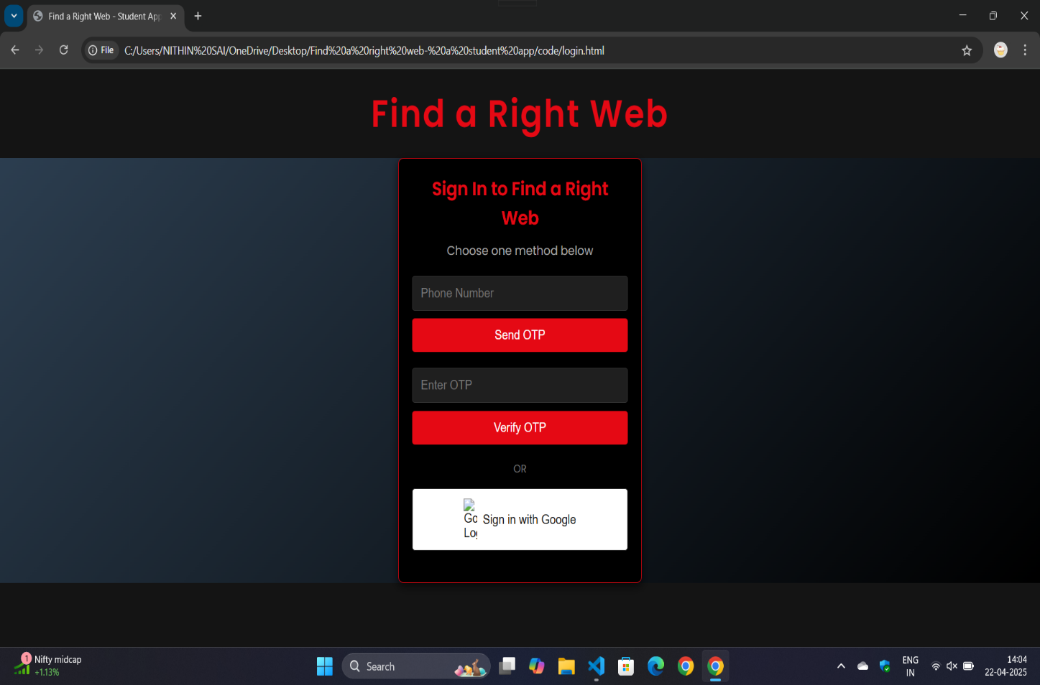

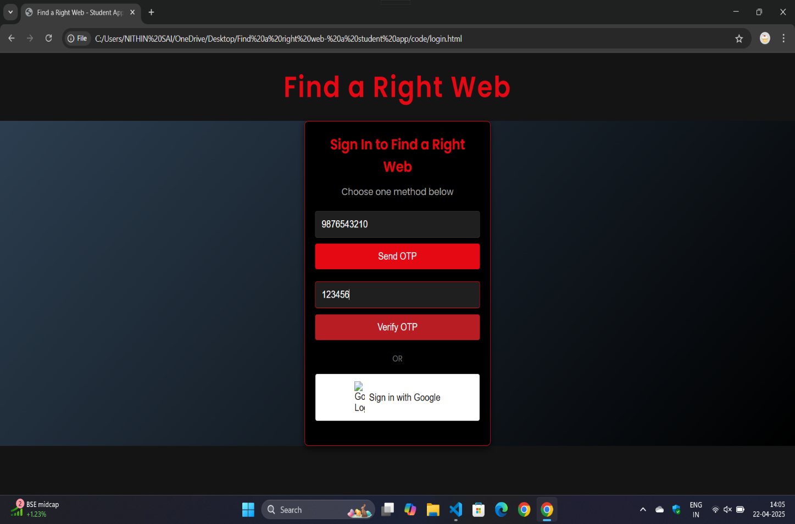

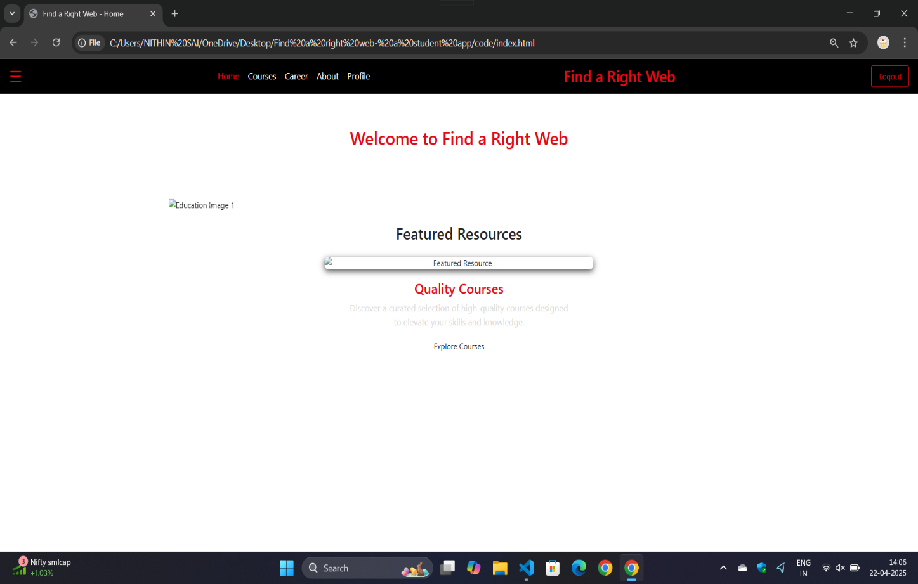

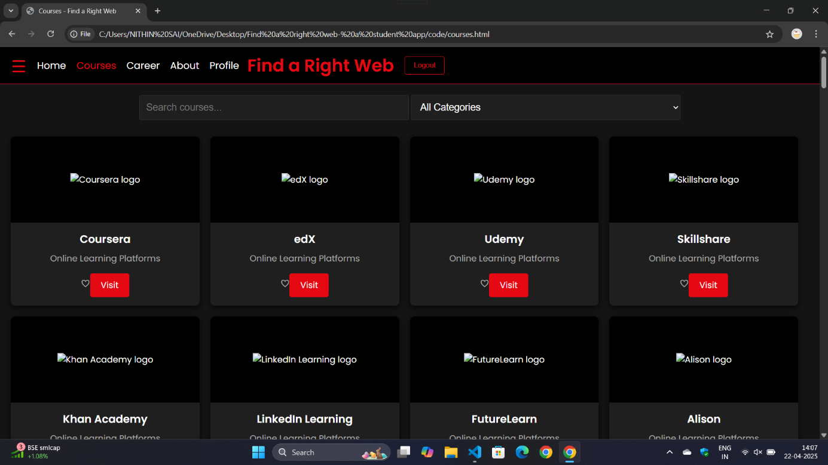

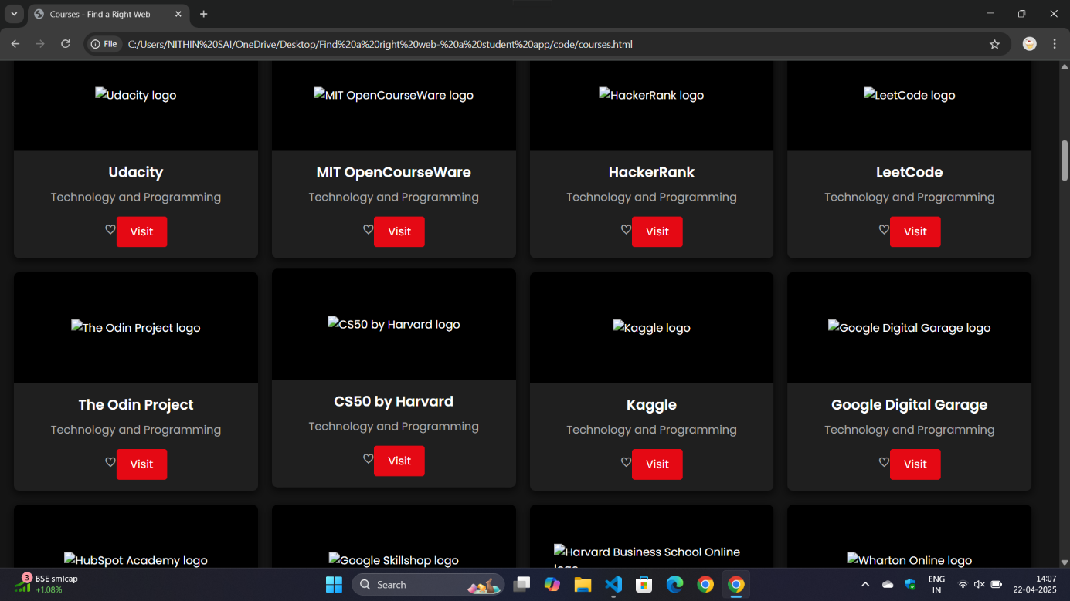

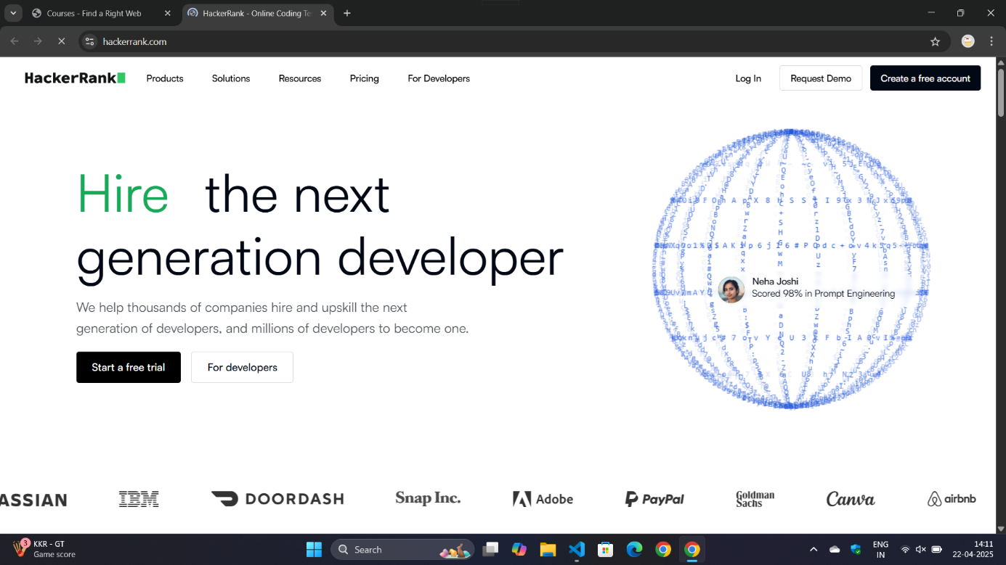

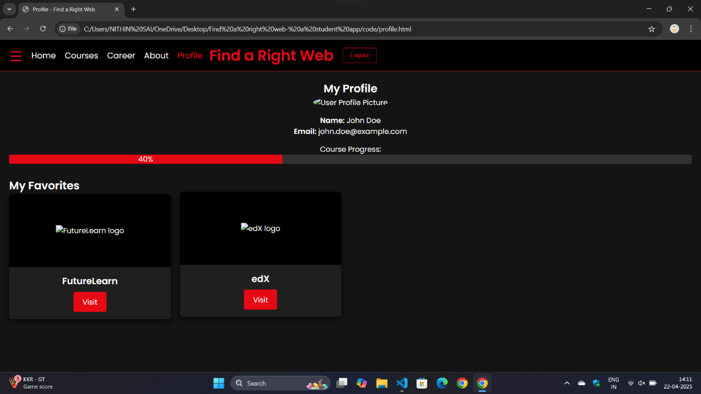

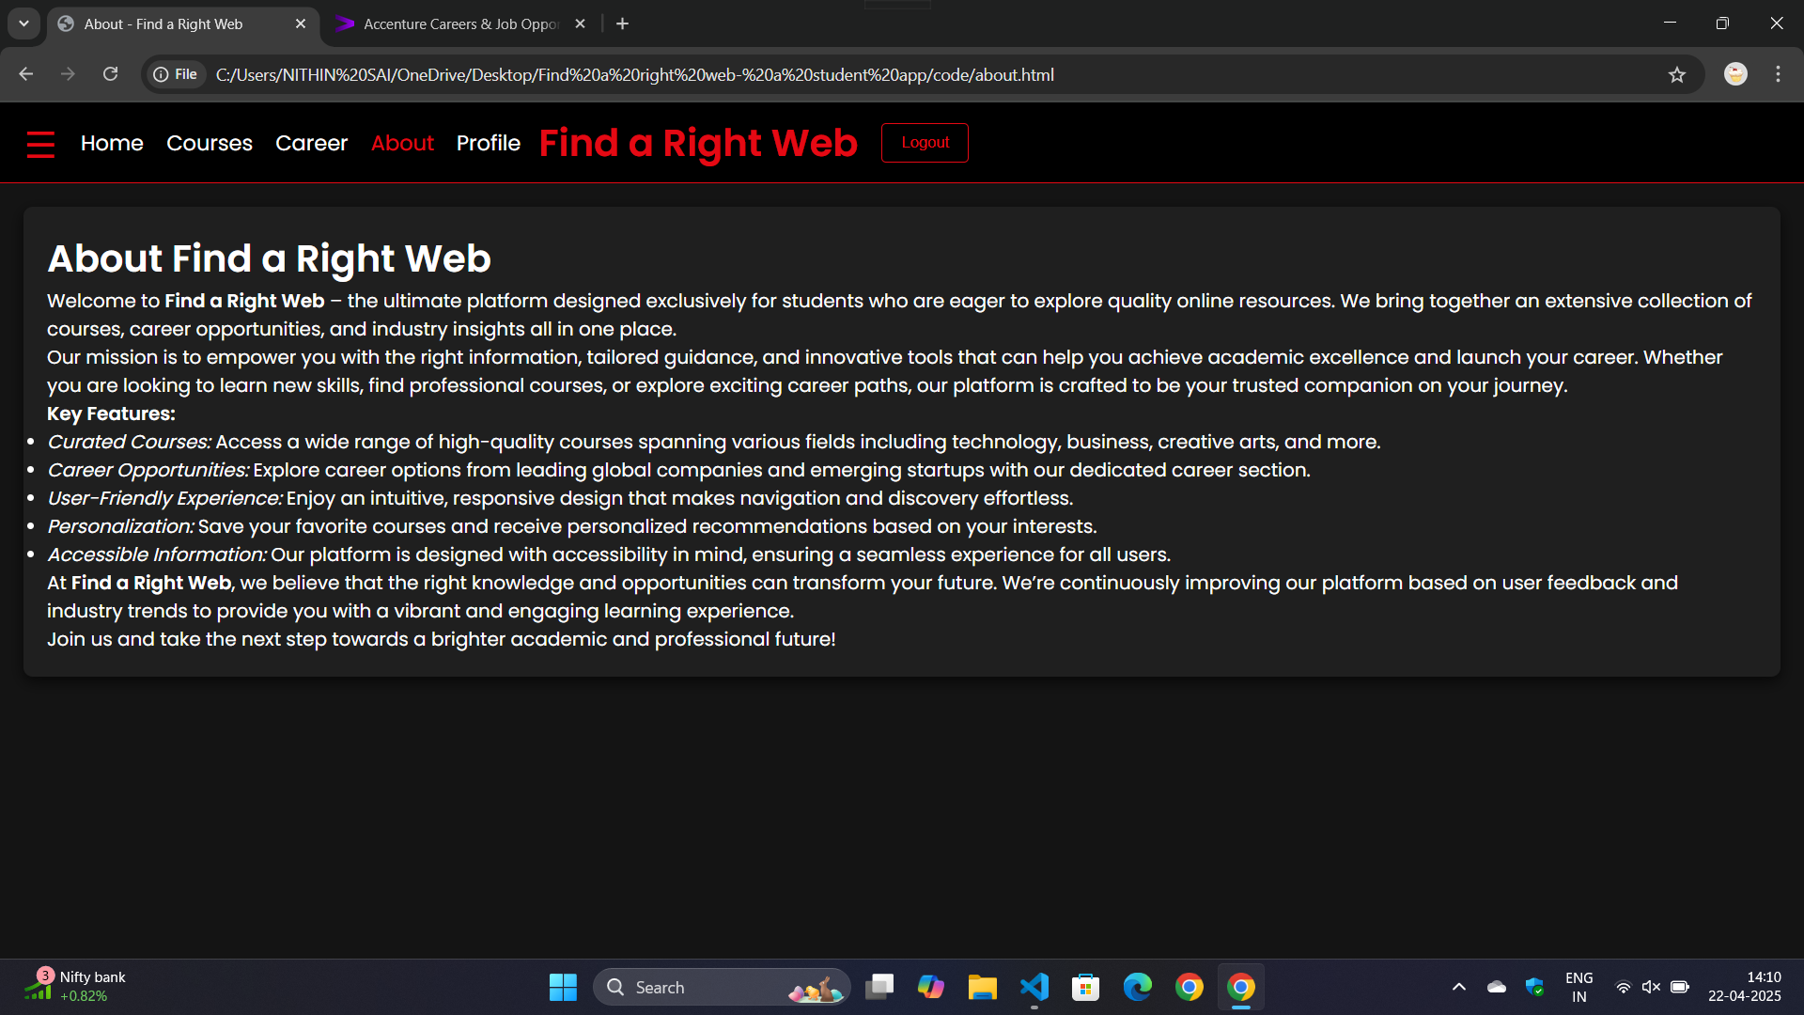

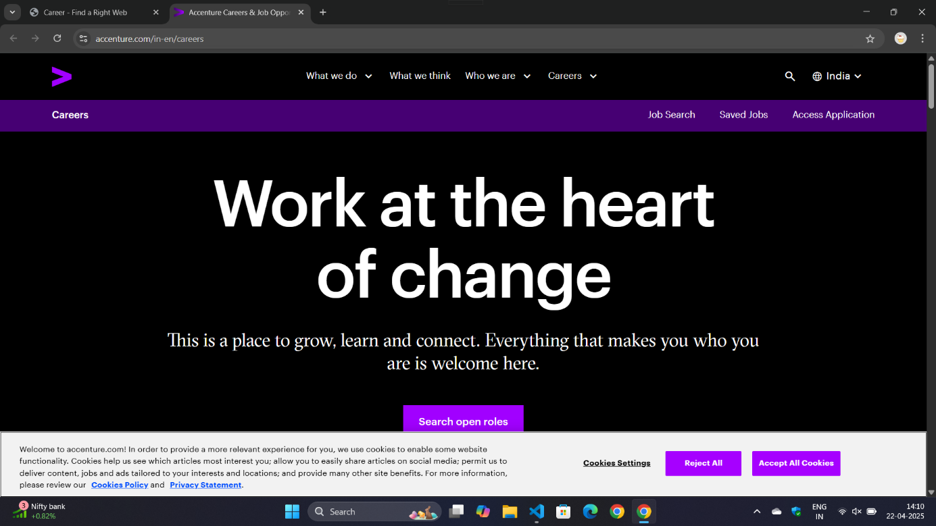

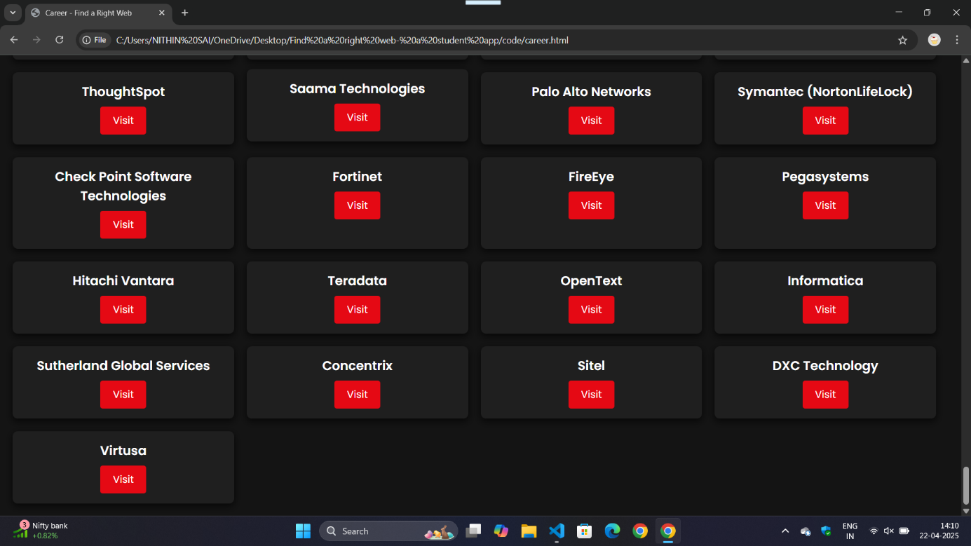

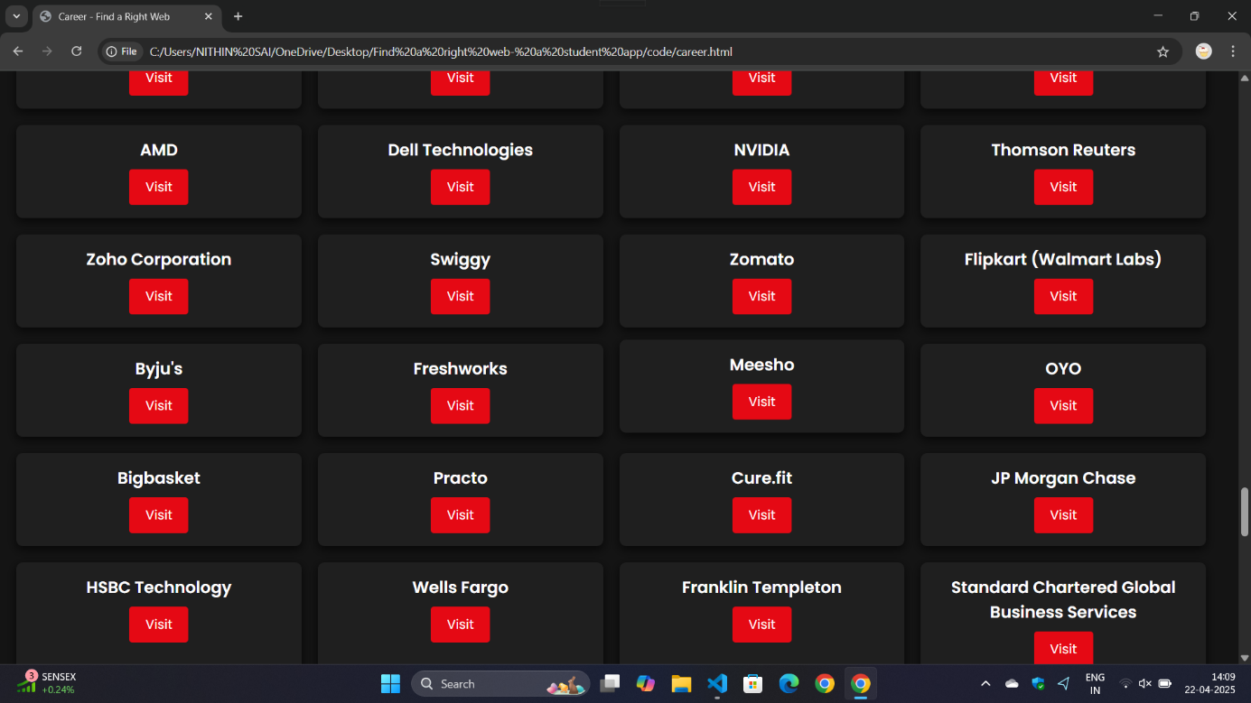

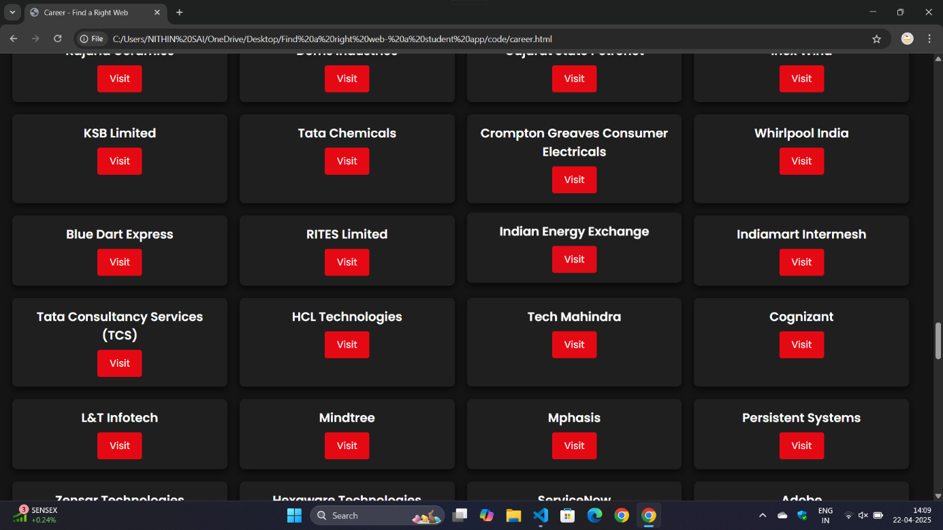

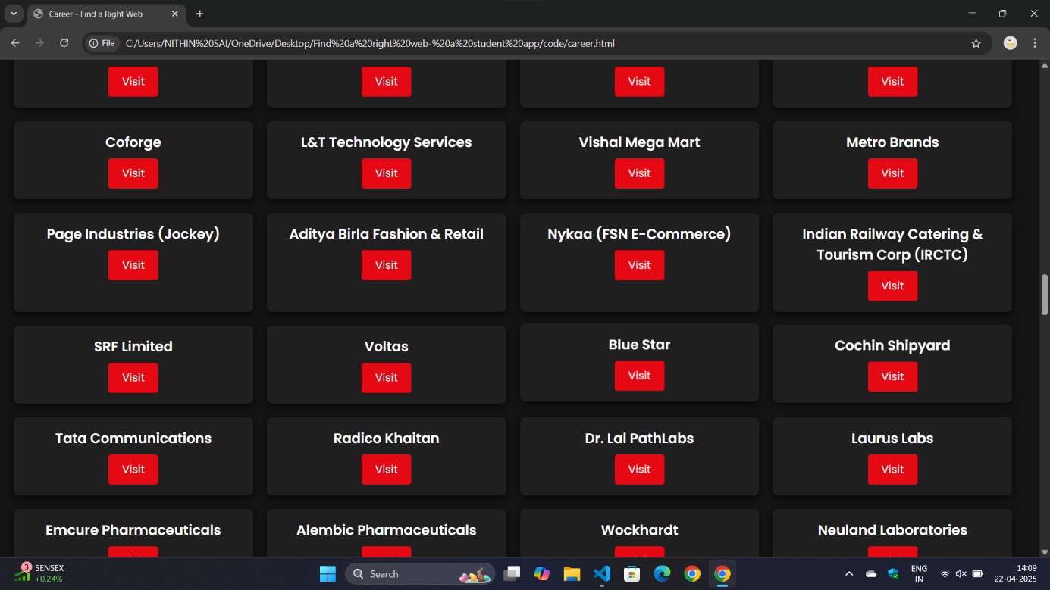

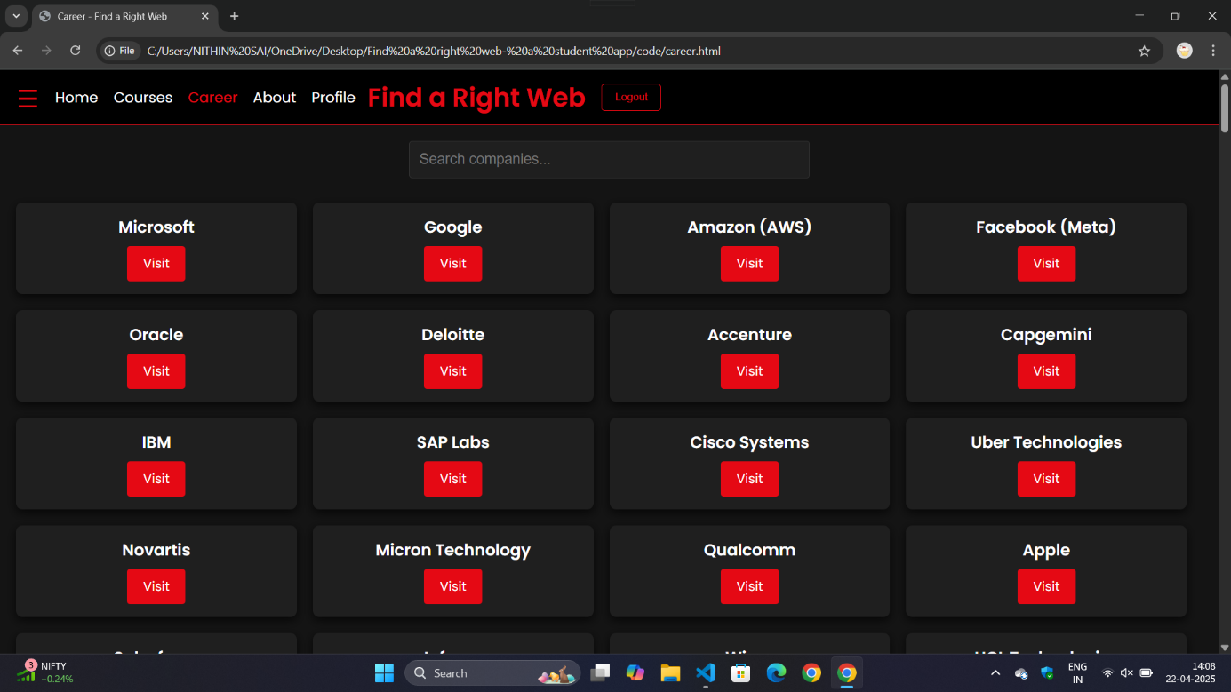

**,10. CONCLUSION**

The project "Find A Right Web: A Student App" aimed to simplify the way students discover educational courses and align their learning with career goals. By integrating information from various e-learning platforms and providing connections to company career portals, the system successfully created a unified and student-friendly interface.

Developed using only HTML, CSS, and JavaScript, the project proves that impactful solutions can be built even with basic web technologies. The system’s features such as filtering, simple AI-based recommendations, and responsive design were implemented effectively, ensuring a smooth and informative user experience.

Overall, this project served not only as a technological solution but also as an educational and practical opportunity to understand full-cycle project development—from planning and data collection to marketing and deployment.

**11. FUCTURE SCOPE**

* **AI-Powered Enhancements**
  + Implement **AI-based career guidance** for students.
  + Advanced **AI-driven course recommendations** using deep learning models.
  + **Chatbot integration** for instant student assistance.
* **Internship & Job Portal Expansion**
  + Integrate **real-time job & internship listings** from multiple sources.
  + Provide **personalized career suggestions** based on user skills & interests.
  + Collaborate with companies for **direct hiring opportunities**.
* **Gamification & Engagement Features**
  + Introduce **leaderboards, achievements, and badges** for active learners.
  + Offer **reward-based learning** with discounts on premium courses.
* **Advanced Filtering & Search Optimization**
  + Implement **smart filters & AI-based search** for better course discovery.
  + Support **multi-language accessibility** for global reach.
* **Mobile App Development**
  + Launch a **dedicated mobile app** with offline learning features.
  + Optimize UI/UX for **seamless navigation & better performance**.
* **Community & Mentorship Features**
  + Introduce **discussion forums & peer networking**.
  + Provide **mentorship programs** with industry experts.
* **Blockchain Integration for Certifications**
  + Store course completion certificates on **blockchain** for authenticity.
  + Enable **verifiable digital badges** for students’ achievements.
* **Global Expansion & Partnerships**
  + Collaborate with **top universities & e-learning platforms**.
  + Support **cross-platform integrations** (Coursera, Udemy, LinkedIn Learning).
* This future roadmap ensures **continuous innovation, scalability, and enhanced user experience**, making the platform **a comprehensive education & career hub**.

# REFERENCES

**12. REFERENCES**

1. **Coursera** – An online learning platform offering courses, specializations, and degrees from universities and companies.  
   Website: [https://www.coursera.org](https://www.coursera.org/)
2. **Udemy** – A popular global marketplace for learning and teaching, with a vast library of courses in various domains.  
   Website: [https://www.udemy.com](https://www.udemy.com/)
3. **W3Schools** – A web developer resource site with tutorials and references on web development languages such as HTML, CSS, JavaScript.  
   Website: [https://www.w3schools.com](https://www.w3schools.com/)
4. **MDN Web Docs (by Mozilla)** – A comprehensive resource for developers, providing documentation on web standards.  
   Website: [https://developer.mozilla.org](https://developer.mozilla.org/)
5. **GitHub Pages** – A platform to host and deploy websites directly from GitHub repositories.  
   Website: [https://pages.github.com](https://pages.github.com/)
6. **Netlify** – A platform for automating the deployment of modern web projects with continuous integration and fast hosting.  
   Website: [https://www.netlify.com](https://www.netlify.com/)
7. **Canva / Figma** – Design tools used for planning and creating user interface mockups for web applications.  
   Websites: [https://www.canva.com](https://www.canva.com/), [https://www.figma.com](https://www.figma.com/)
8. **Google Scholar** – Used for reviewing related research papers during the literature survey phase.  
   Website: [https://scholar.google.com](https://scholar.google.com/)

* A Recommendation System for Online Courses
* Career-Based Explainable Course Recommendation
* Hybrid Course Recommendation System Design for a Real-Time Student Automation Application
* Enter a Job, Get Course Recommendations
* Integrating Career Development Learning into the Curriculum
* An Online Course Recommender System in e-Learning Using Learners' Profiles and Learning Behavior
* Designing a Course Recommendation System on Web Based on the Students' Course Selection Records
* Building a Recommendation System to Assist Students in Choosing Elective Courses